**5.2 Data Analysis:**

The given table shows us the safe level concintration for a good quality of air. Our motive was taking data from different place and comparing the value of data. So we took data from two place Uttara and Bohundhara with the gps controlled drone.

|  |  |
| --- | --- |
|  |  |
| Pollutants | **Safe Level Concentration** |
| Carbon monoxide (CO) | **50ppm** |
| Nitrogen oxide(NOx) | **350ppm** |
| Sulphur dioxide (SO2) | **5ppm** |
| Particulate Matter (PM2.5) | **0.489ppm** |
| Particulate Matter (PM10) | **0.244ppm** |
| Ozone (O3) | **0.1ppm** |

**Data taken From Uttara:**

|  |  |  |  |  |  |  |  |
| --- | --- | --- | --- | --- | --- | --- | --- |
|  |  |  |  |  |  |  |  |
| **CO** | **converted CO** | **LPG Raw** | **LPG converted** | **Dust Raw** | **Dust Conv.** | **NOx Raw** | **NOx converted** |
| 101.72 | **88.79** | **309.877551** | **309.877552** | 151.18 | **46.82** | 149.9130435 | **79.66** |
| 102.40816 | **89.39** | 294.175 | **472.35** | 152.1 | **47.1** | 150.6 | **80.03** |
| 108.58 | **94.78** | 295.84 | **448.42** | 158.64 | **49.13** | 149.98 | **79.7** |
| 107.85 | **94.14** | 300.88 | **450.95** | 152.36 | **47.18** | 150.88 | **80.18** |
| 106.86 | **93.28** | 301.42105 | **458.64** | 152.0612245 | **47.09** | 157.2 | **83.54** |
| 106.6 | **93.05** | 1 | **459.46** | 153.36 | **47.18** | 151.1 | **80.3** |
| 107.05128 | **93.45** | 1 | **1.52** | 163.7755102 | **50.72** | 150.8367347 | **80.16** |
| 1 | **0.87** | 1 | **1.52** | 160.825 | **49.8** | 152.06 | **80.24** |
| 1 | **0.87** | 1 | **1.52** | 162.12 | **50.21** | 162.3469388 | **86.27** |
| 1 | **0.87** | 1 | **1.52** | 162.16 | **50.22** | 159.35 | **84.68** |
| 1 | **0.87** | 300.66667 | **1.52** | 162.5 | **50.32** | 161.06 | **85.59** |
| 1 | **0.87** | 479.28205 | **458.31** | 1 | **0.31** | 161.18 | **85.65** |
| 86.666667 | **75.65** | 509.16216 | **730.58** | 1 | **0.31** | 161.3947368 | **85.77** |
| 286.79487 | **250.34** | 510.06667 | **776.12** | 1 | **0.31** | 0.857142857 | **0.46** |
| 333.83784 | **291.41** | 504 | **777.5** | 1 | **0.31** | 1 | **0.53** |
| 329.33333 | **287.48** | 472.13333 | **768.25** | 1 | **0.31** | 1 | **0.53** |
| 228.33333 | **199.31** | 414.38095 | **719.68** | 137.6666667 | **42.63** | 0.979166667 |  |
| 302.42222 | **263.99** | 359.33333 | **631.65** | 289.7179487 | **89.72** | 1 | **0.53** |
| 272.19048 | **237.6** | 362.7619 | **547.74** | 361.972973 | **112.1** | 136.3333333 | **72.45** |
| 173.33333 | **151.3** | 361.5 | **552.96** | 360.6428571 | **111.69** | 287.3076923 | **152.68** |
| 234.45455 | **204.66** | 346.62 | **551.04** | 238.5 | **73.86** | 357.2972973 | **189.87** |
| 173.75 | **151.67** | 328.37931 | **528.36** | 316.7333333 | **98.09** | 356.1333333 | **189.25** |
| 234.38 | **204.59** | 293.38298 | **500.55** | 297.4285714 | **92.11** | 237 | **125.94** |
| 221.48276 | **193.33** | 296.64 | **447.21** | 179 | **55.43** | 313.0222222 | **166.34** |
| 102.75 | **89.69** | 293.32 | **452.17** | 230.1428571 | **71.27** | 292.952381 | **155.68** |
| 103.1 | **90** | 295.14 | **447.72** | 178.25 | **55.2** | 176.5 | **93.79** |
| 100.98 | **88.15** | 307.58 | **449.89** | 233.34 | **72.26** | 227.2380952 | **120.76** |
| 101.65306 | **88.73** | 289.62 | **468.85** | 228.2068966 | **70.67** | 176.25 | **93.66** |
| 101.58 | **88.67** | 294.32 | **441.67** |  |  | 229.24 | **121.82** |

|  |  |  |  |
| --- | --- | --- | --- |
|  |  |  |  |
|  |  |  |  |
| Table: Taken Data From Uttara.  if we see these data, we can esily compare these data with the table(safe level) and it is exceeding the safe level concintration. |  |  |  |
|  |  |  |  |
|  |  |  |  |
|  |  |  |  |
|  |  |  |  |
|  |  |  |  |
| Fig: Air quality monitoring at Uttara (Using Blynk). |  |  |  |
|  |  |  |  |
| Fig: Barchart of CO Data( Green colow stands for CO). (Using Blynk)    Fig: Barchart of Methane Gas/LPG(orange stands for Methane). (Using Blynk)    Fig: Barchart of Methane Gas/LPG(Magenta Pink stands for Methane). (Using Blynk) |  |  |  |
|  |  |  |  |
|  |  |  |  |
|  |  |  |  |
|  |  |  |  |
|  |  |  |  |
|  |  |  |  |
|  |  |  |  |
|  |  |  |  |
|  |  |  |  |

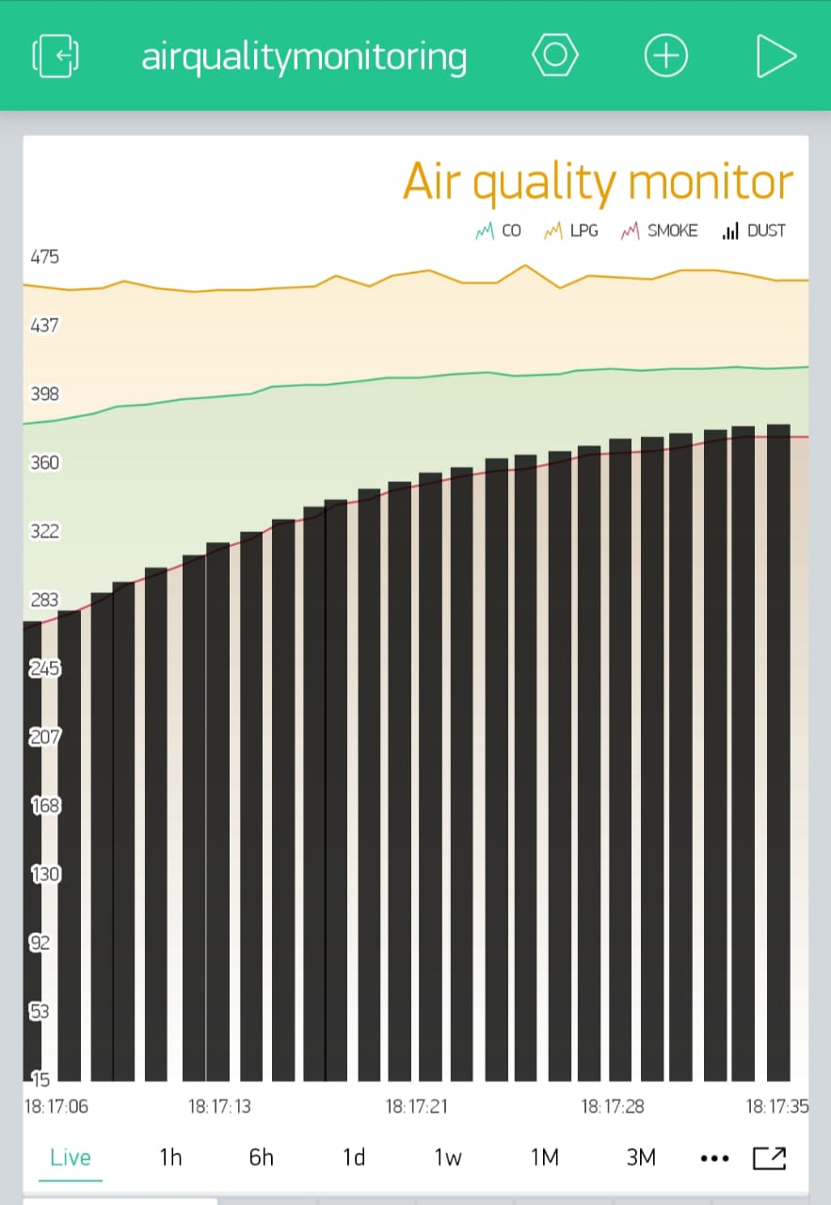

Fig: Barchart of Dust(Black stands for Methane). (Using Blynk)

From the data from uttara, we can see that the cocintration of each gases which were our projectparameters, CO, NOx, Methane, Dust these exceeds the safe level concintration.

**Data taken From Bashundhara:**

|  |  |  |  |  |  |  |  |
| --- | --- | --- | --- | --- | --- | --- | --- |
| **CO= V1** | **ppm** | **LPG= V2** | **ppm2** | **V3 = NO2** | **ppm3** | **V4= Dust** | **ppm4** |
| 200 | **174.58** | 189.263 | **288.5** | 188.9333 | **100.4** | 189.34 | **58.64** |
| 200 | **174.58** | 189.34 | **288.61** | 189.4 | **100.65** | 189.89 | **58.81** |
| 147.706 | **128.93** | 189.666 | **289.11** | 189.666 | **100.79** | 189.92 | **58.82** |
| 189.215 | **165.17** | 190.804 | **290.85** | 190.323 | **101.14** | 189.32 | **58.63** |
| 189.35 | **165.328** | 190.0425 | **289.68** | 189.3984 | **100.65** | 190.39 | **58.96** |
| 189.75 | **165.65** | 190.524 | **290.42** | 186.8852 | **99.31** | 162.78 | **50.41** |
| 189.78 | **165.66** | 163 | **248.46** | 174.4522 | **92.7** | 76.56 | **23.71** |
| 191.5416 | **167.2** | 77.5064 | **118.14** | 123..169 | **65.36** | 76.33 | **23.64** |
| 188.07 | **164.17** | 77.25 | **117.75** | 127.566 | **67.79** | 73.66 | **22.81** |
| 189.23 | **169.382** | 74.41666 | **113.43** | 126..9 | **66.96** | 75.43 | **23.36** |
| 189.21 | **165.16** | 73.35 | **111.81** | 126.5 | **67.22** | 73.33 | **22.71** |
| 184.942 | **161.44** | 76.96 | **117.31** | 124.75 | **66.29** | 75.5 | **23.38** |
| 149.8 | **130.76** | 70.966 | **108.17** | 122.633 | **65.17** | 72.75 | **22.53** |

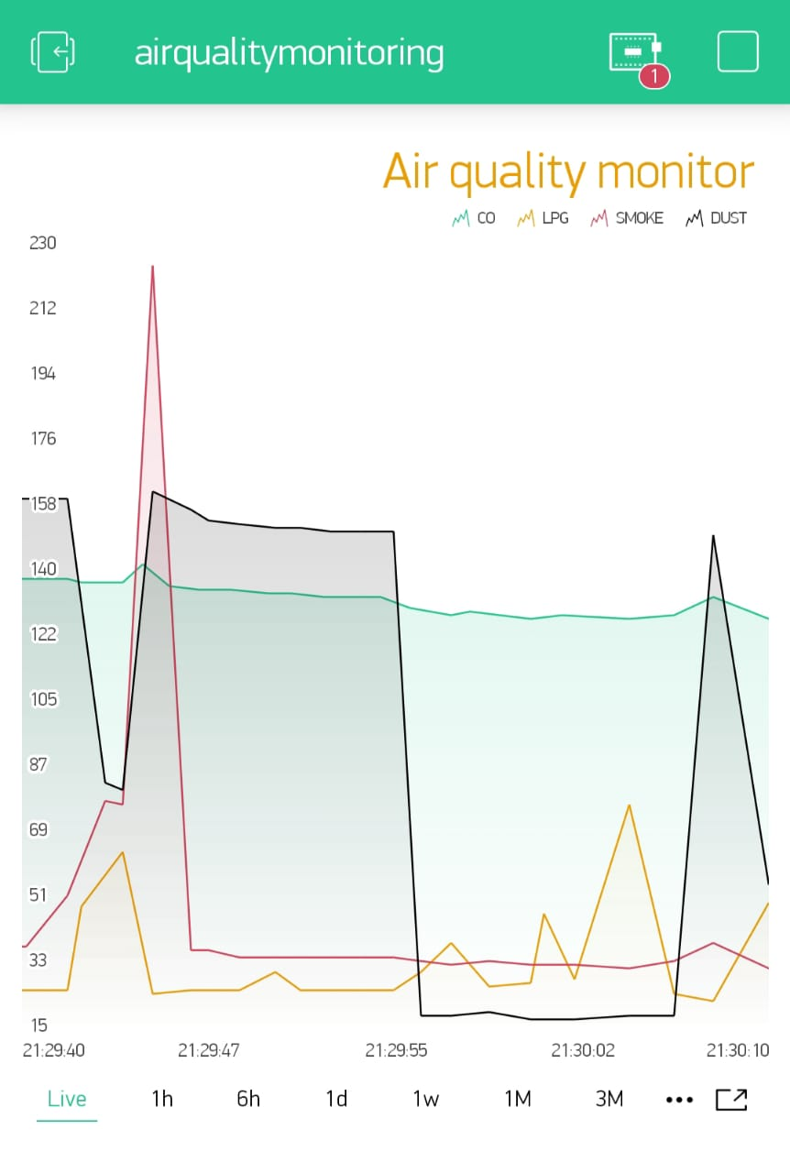

Fig: Line chart of Bashindhara (Using Blynk).

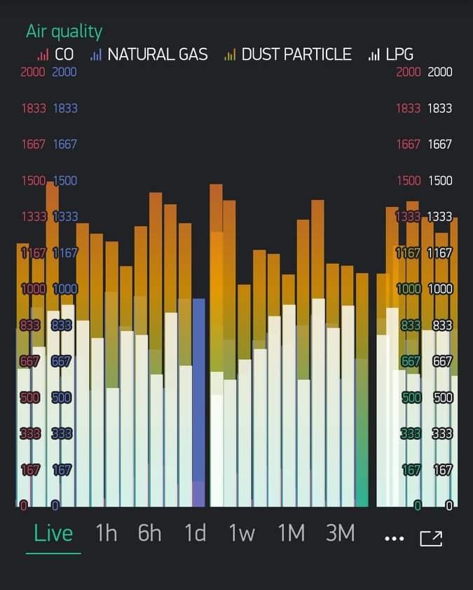

Fig: Barchart from Blynk for Bashundhara.

**Pi chart analysis for Boshundhara:**

we analysis the data using line graph and bar graph. These graph shows the live streaming data. Then we took snaps from our smart phone to record these data.We can clearly make a decison that the air quality of Dhaka is not that good,actually it is harmful,this is the reason why Dhaka paced first position in WORLD Ranking of AQI. this air day by day getting toxic hazards human health. incresing the rate of illness. there were also another options to design our project interface.We can add any button, slider and other designs as well in local blynk server.

**5.2 Discussion:**

We've done building our drone in EEE499A. Then we have completed the set up making using required components. It was the most complex part and an important part of our project. it was really difficult to function all the parts of the project together. As we have both hardware and software part in our project. we had drone, a components set up, and had to calibrate this with coding and software. wehad to look after evrey parts at a same time, had to cotrolled everything together. we had checked over and over if the nodemcu sends its data to the server properly or not,then we had to connect all the system in a same wifi line, otherwise the NodeMCU can not properly sends its data to the server. also there were actually so many steps that we have followed for getting data with properly flying Drone. In drone, Per motor draws 2A while hovering. So, 4 motor draws 8A for hovering in the air. Our selected battery is 2.2Ampere/hour. That means it can delivery 2.2A for 1 hour (60minutes).

**The calculation**,

2.2A delivers 60 minutes 1A delivers 60x2.2 minutes 8A delivers (60x2.2)/12 minutes =16.5 minutes (theoretically, moderate air condition) Practically it varies from 12-14 minutes.

Theoretically, the range of our drone is 1KM, but practically it varies from 600-800 meters depending on the weather. Transmitter to the receiver must communicate via 2.4Ghz. 6 individual channels mean 6 separate PWM values. But technically it shows some variations. Usually, we use ’mission planner' from the laptop or 'Droid planner' from mobile to select the specific path for the Drone, but in case of an error, we alternatively use a remote to control the drone. We give the input from Mobile/Laptop then it flies accordingly and returns at the same place. We use Soldering iron, Screw box, Hex screw, Double side tape as supporting tools.

Approximately we got 10/12 mins for flying drone, in these short period of time we have maneged for taking data. Flight time decreses because of connecting set up with the same lipo battery. Having all these difficulties,finally we have achived our goals successfully what we designed and planned to complete our project. We worked really very very hard to make the project successful. Besides,there are some limitations:

1. If hardware cannot perform well then takin data will be a great problem for this project.